Previous year problems:
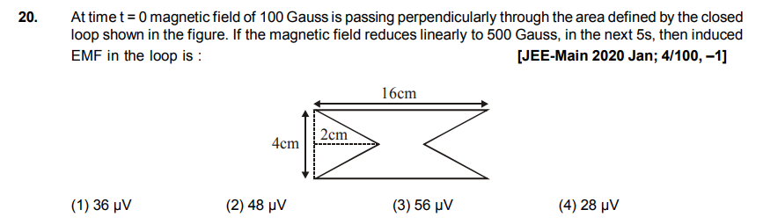

Answer:
(3) Simple application of Faraday’s law. Calculate the area of the loop, hence calculate the flux. In |V| = dΦ/dt use dt to be the given small time.

